**Excel Assignment – 14**

1. How much Diamonds were looted from Chennai Port Trust?

7182 diamonds were looted from Chennai port trust.

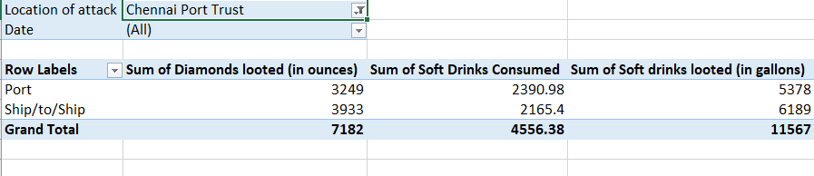

1. How many Ships were looted near Paradip Port Trust and Chennai Port Trust?

Six ships were looted near Pradip port trust and Chennai port trust.

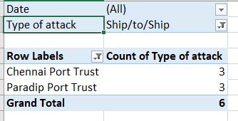

1. What is the sum total of Diamonds looted from the V.O. Chidambarnar port trust?

The sum total of diamonds that were looted from the V.O. Chidambarnar port trust are 9887 ounce.

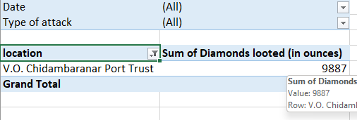

1. What is the average amount of Diamonds and Soft drinks looted?

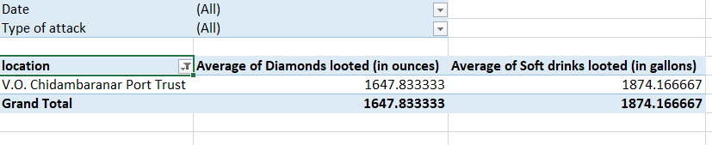

1. What is the ratio of soft drinks drunk to soft drinks looted?